Over past years, the use of automobiles have become more common with the increasing complexity of human lives. In Sir Lanka for any vehicle, it is must to have a motor vehicle insurance before using the vehicle. The growth in the automobiles usage in the country has led to the establishment of insurance companies and it has become a competitive market segment in the industry. In the Fitch ratings it is stated that “Intense pricing competition in the motor segment is likely to hold the combined ratios in non-life above 100%”. Due to fall in imports with increased customs duty and unfavorable exchange rate movements, growth in the motor sector has dropped to 16.49 % in 2012 (2011: 29.56%). Yet, the influence of the motor segment in non-life remained high at 63.64% and will remain the major GWP contributor in non-life (Fitch ratings, 2014).

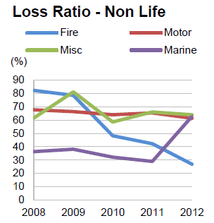

Motor vehicle industry can be considered as an industry where there is a constant financial flow in-and-out with respect to a company. It is argued that cost savings and efficient process improvements in claims management business processes have a great impact on the key performance indicators of insurers(Baecker and Bereuter, 2010). The main reasons why cost savings are hard to achieve include the late involvement of insurers after car accidents, the limited integration of business partners such as repair shops, and improper information about the case circumstances (Kaeslin and El Hage 2008). As indicated by Capegemini 2013, Mobility has been acknowledged as a growing phenomenon in the insurance industry.

It can be seen that with the help of latest technologies average claim life-cycle from set-up to close can be shortened as well as decrease the average costs per case since in contrast current motor vehicle insurance claiming procedure drags on for weeks to complete

References

Flitch Ratings 2013, *2014 Outlook: Sri Lanka Insurance Sector,* Outlook Report.

Retrieved September 17th 2014 from [www.fitchratings.lk/download-article-216.pdf](http://www.fitchratings.lk/download-article-216.pdf)

Baecker, O., & Bereuter, A. (2010), *Technology-Based Industrialization of Claims Management in Motor Insurance,* Institute of Technology Management, University of St. Gallen.

Retrieved September 10th 2014, from the University of St. Gallen i-lab website: <http://www.i-lab.ch/docs/04_technology> based_industrialization_of_claims_management_in_motor_insurance.pdf